The COMET Workshop, 3 April 2013, Kyoto, Japan

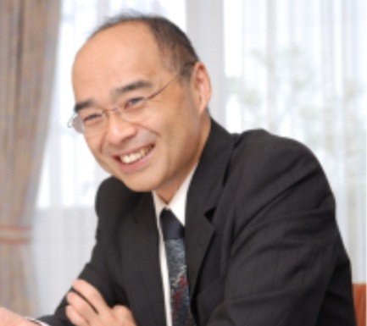  Professor Toshiaki Furukawa | Earlier this month, Paula, Liz and Mike were delighted to run the first COMET workshop in Japan, at Kyoto University, alongside Professor Toshiaki Furukawa (Professor and Chair, Department of Health Promotion and Human Behaviour Professor, Department of Clinical Epidemiology, Kyoto University) and Dr Rintaro Mori (Head, Department of Health Policy National Centre for Child Health and Development, Tokyo).
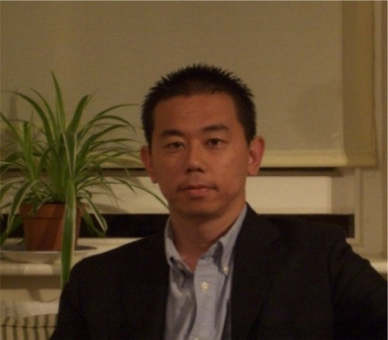  Dr Rintaro Mori | We arrived as the cherry blossoms began to open across the city, and were lucky enough to experience them in full bloom, creating a spectaular backdrop for the sessions. The workshop received more interest than we anticipated, with 80 people attending from all over Japan. After much practice, Paula gave an impressive welcome and introduction to the day in Japanese, which seemed to translate well as the audience laughed at just the right moment!
The concept of a core outcome set was new to many in the workshop, but it was well received and understood over the course of the day. The active participation of over 80 people in small groups made the whole event a huge success, and great thanks are due to the facilitators who helped ensure that the instructions were clear and everybody was on the right track.  Feedback from particpants showed that they |  | 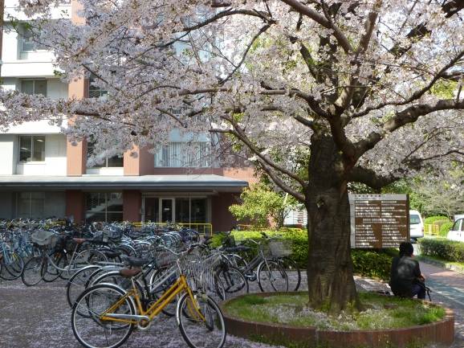
found the workshop to be both useful and interesting, and Professor Furukawa has already received many enquiries from people wanting to get involved or collaborate in work on core outcome sets. After the success of this workshop, we hope very much that the coming months and years will contain many opportunties to engage Japanese collaborators in the development of core outcome sets and in future COMET activities.

The workshop was made possible with funding from the Great Britain Sasakawa Foundation.

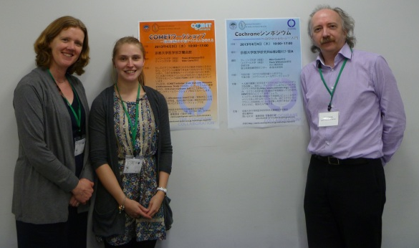
Professor Paula Williamson, Miss Elizabeth Gargon and Professor Mike Clarke

